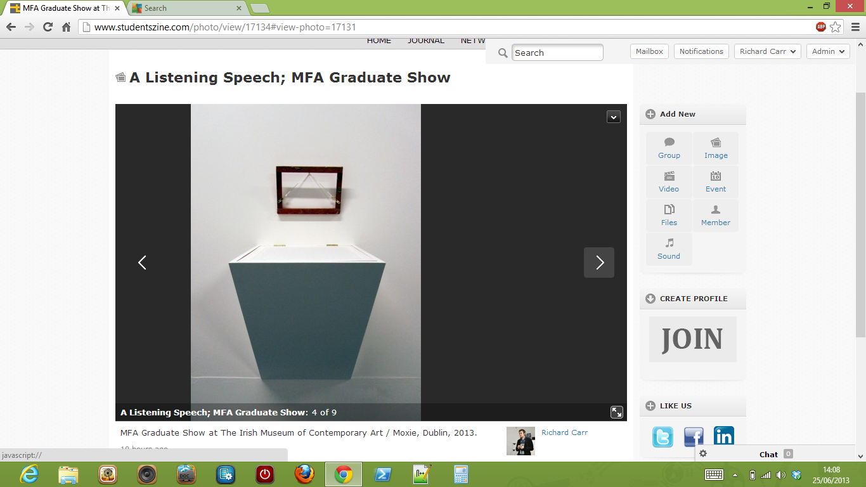

**IMAGE DISPLAYS TO RIGHT OF VIEWER IN ‘VIEW PHOTO’ NOT IN POP-UP VIEWER.**

